Travis Sands

10/19/2024

CS – 320 Testing and Automation QA

Dr Cross

**Summary and Reflection**

When testing my code, I wanted to ensure that the requirements were being met and tested for. For example, in the appointment service project, the appointment could be a date in the past. By testing the date for a previous day, this will ensure that the date is in the future. You can also see that the requirements were set inside of the requirements as well. Ensuring that if the input does meet the requirements, it will function properly.

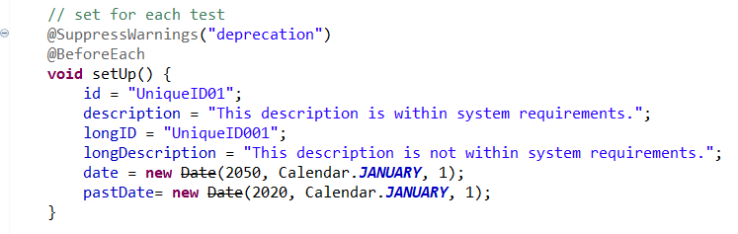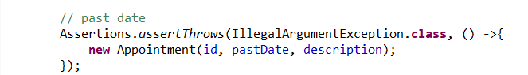

To ensure that my code is technically sound I did things like Before Each test. This is helpful when maintaining the system. Say the requirements were to change. They can easily be updated without having to change every line of code. If the Task Service needed to be updated to allow for the task description to be updated to sixty characters the only thing that would have to be changed is the character length of the description. Looking below you can see how easy it would be to update. The other test calls on these objects without changing every line.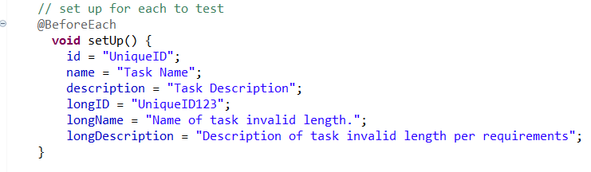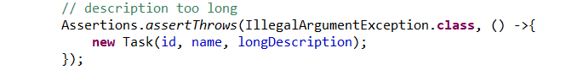 For instance, if you take the longDescription, the only thing that must change is the longDescription in the Before Each test, and it can continue to be used in other tests if necessary. The other thing I did when testing was testing for null entries, giving better coverage. Though this is not shown it helps with being technically sound and testing all requirements.

I really like using before each testing as it can be easily updated and used repeatedly without having to update multiple lines of code. It ensures technical soundness, as well as creating cleaner code. Both of which are important when coding and testing code. With that testing all requirements are met and are important.

When testing I wanted to ensure that if the entry were null then it would not pass, but if the requirement was met then the test would pass. Testing all requirements whether they are met or not met shows us that the code is functioning properly.